COUNCIL WEEKLY UPDATE
June 2, 2022

PLANNING

General Plan Update Phase 2 – On May 23, the Planning Commission reviewed and heard public testimony on project alternatives for the General Plan Update. The Planning Commission expressed unanimous support for the staff-recommended preferred plan (Alternative B), which aligns with the Community Vision (accepted by the City Council in November 2021) and the Draft Sustainable Corridors Plan (delivered to the City Council on March 28, 2022). The proposed project alternatives will come before the City Council on June 22. The associated Alternatives Report can be accessed on the GPU project webpage at onwardoceanside.com

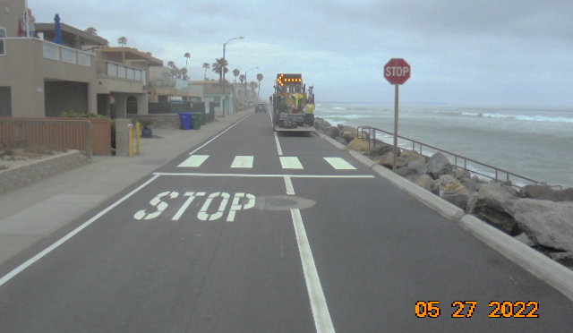
ENGINEERING

Street Overlay Project – All road improvements have been completed for the Measure X-funded Strand overlay project (photo right). Staff have advertised bids for the next combined Slurry Seal and Street Overlay projects and anticipate requesting City Council approval to award a construction contract at its June 22 meeting. Upon City Council approval, work may start in early August.

Annual Slurry Seal Project – Due to overlapping street locations, staff has incorporated and scheduled several Slurry Seal projects to coincide with the Street Overlay Project, as feasible.

Beachfront Improvements Phase 1– Final portions of construction of the future Police Substation, maintenance building, and public restrooms continued this week. Interior paint, mechanical / electrical finishes and trims, caseworks, and landscaping are in their final stages of completion. Wood doors/windows are under construction at future Police substation. Gravel will be placed on low flat roofs and rain gutters are being installed at the maintenance building. Corrective work is underway per the preliminary punch-list walk conducted last week. Remaining portions of the site electrical control system are nearly complete.

College Blvd. Widening from Barnard Dr. / Waring Rd. to Old Grove Rd. – The consultant is finalizing the standard roadway cross sections per staff comments. Staff and the consultant are scheduled to meet with North County Transit District staff on June 6 to receive feedback on the proposed scope of work; information received will be incorporated into the design. Staff and the consultant are also scheduled to meet with representatives of the Rancho Del Oro HOA on June 6 regarding the project scope and receive feedback.

Brooks Street ADA Project – The final outreach meeting to inform the public of the project was held at the Crown Heights Resource Center on May 26. Contract documents have been routed for final signatures.

Butler Street Storm Drain Lining Project – Project materials are estimated to be delivered by June 13, in time for start of construction in early July.

Cleveland Storm Drain – California Coastal Commission (CCC) staff have requested additional information on the design of the proposed outfall. The consultant is preparing a response to CCC that will be discussed at a meeting scheduled in July.

Grandview Sidewalk In-Fill Project - Construction documents have been completed. The consultant is working towards finalizing the required easement.

WATER UTILITIES

Community Choice Energy: Clean Energy Alliance (CEA) to be considered at June 8 Council Meeting - Consistent with previous direction given by City Council, staff will recommend adoption of a resolution authorizing the City’s membership in the Clean Energy Alliance, a local community choice energy provider, at the upcoming June 8, 2022, Council meeting. Since the September 2021 Council workshop on Community Choice Energy, the cities of San Marcos and Escondido have formally joined CEA. Additionally, the City of Vista intends to consider membership at their upcoming June 28, 2022, Council meeting. The City of San Clemente has also expressed interest in membership with CEA. If membership is approved, the City of Oceanside’s approximate 73,000 electric customer accounts will make up 23 percent of CEA’s total service area; CEA will be responsible for procuring power generation contracts while transmission, grid maintenance and billing services will remain through SDGE.

PUBLIC WORKS

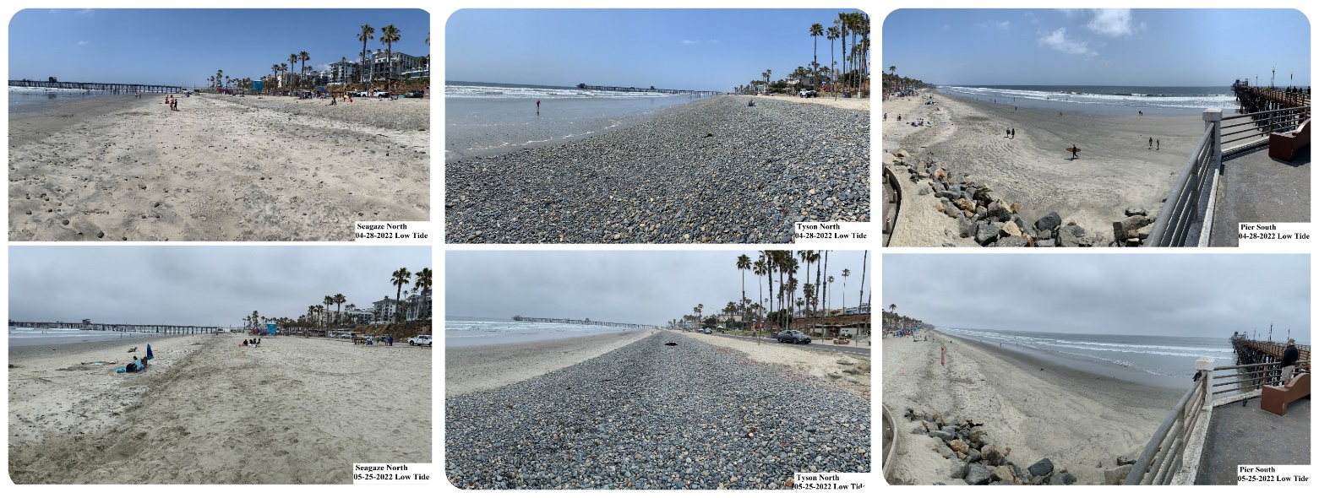
Harbor Dredge Update - The US Army Corp of Engineers completed the annual dredge of the Harbor inlet. By Wednesday, May 25, all equipment, vessels and dredge pipe had been removed from the beach and Harbor. The official amount of dredged sand placed on City beaches met the contracted amount of 245,000 cubic yards of sand. Grunion runs and large south swells created some delays, however Manson was still able to meet the contract requirements before the Memorial Day weekend started. The City was awarded $1,790,000 towards the 2022 dredge and provided another $500,000 of workplan funds for a total contribution of $2,290,000. Camp Pendleton matched those funds, adding another $2,290,000. The City of Oceanside contributed an additional $600,000 towards this year’s dredge cycle, bringing the combined total to $5,180,000. (Before/ after photos are shown below: Left: Seagaze looking north. Middle: Tyson looking north. Right: Pier looking south).
LIBRARY

Summer Reading Programs - Oceanside Public Library invites children, teens, and adults to participate in Summer Reading 2022 by signing up online at oceansidepubliclibrary.org. All ages earn prizes and are invited to attend literacy-based, educational and fun events from June 1 through August 6, 2022. This year’s theme is “Read Beyond the Beaten Path,” with a focus on expanding horizons through new reads, the many different experiences summertime offers and the Library’s Community Health and Well-being Initiative. The Community Health and Well-being Initiative promotes getting outdoors and connecting with nature through new services, such as the Library’s seed library and California State Park Passes available for check out. Summer Reading and the Community Health and Well-being Initiative are sponsored by the Friends of the Oceanside Public Library.

21st Annual Filipino Cultural Celebration - The Filipino-American Cultural Organization (FACO) and the Oceanside Public Library will be hosting the event on Saturday, June 4, 2022 from 12:00 to 6:00 p.m. Enjoy traditional dances, a cultural fashion show, children’s crafts, delicious food and much more. Event admission is free and open to the public.

Grand Opening of Jane & Evie’s Used Books, a Friends of the Oceanside Public Library Bookstore. The grand opening event will be held on Thursday, June 9, from 11:00 a.m. to 2:00 p.m. at 323 North Coast Highway in Oceanside. The celebration will include a ribbon-cutting ceremony at noon, guest speakers, light refreshments and giveaways. The Friends of Oceanside Public Library opened Jane & Evie’s Bookstore to offer a storefront opportunity to purchase gently used books, DVDs and CDs, puzzles and a rotating inventory of other items, such as framed artwork. The store’s name honors both the late Jane Cheadle and Evie Magaña, Friends who devoted many years of service to the Library and the community.

PARKS & RECREATION

Camp Participant News - Parks and Recreation has partnered with with Feeding San Diego to provide no-cost breakfast and lunch to the SUNsational camp participants at both Melba Bishop Recreation Center and the John Landes Community Center. The SUNsational Camp program has been a staple of Oceanside Parks and Recreation summer offerings for many years and we are excited to now bring this program to the John Landes area.

COMMISSION / Committee MEETINGS

June 7 Special Parks & Recreation Commission Meeting. 6:00 p.m.
June 13 Planning Commission. 6:00 p.m.
June 20 Harbor & Beaches Advisory Committee. 5:00 p.m.
June 27 Planning Commission. 6:00 p.m.
June 28 Library Board of Trustees. 2:00 p.m.
June 28 Housing Commission. 6:15 p.m.
July 11 Planning Commission. 6:00 p.m.
July 12 Parks and Recreation Commission Meeting. 6:00 p.m.
July 18 Buena Vista Lagoon Joint Powers Committee. 3:30 p.m. Virtual
July 21 Police and Fire Commission. 4:00 p.m.
July 25 Planning Commission. 6:00 p.m.
July 26 Library Board of Trustees. 2:00 p.m.
July 26 Housing Commission. 6:15 p.m.

COMMUNITY MEETINGS / EVENTS

June 3 First Friday Art Walk. 5:00 - 9:00 p.m.

June 3-5 Beach Soccer Championships. Harbor Beach.

June 4 Free 10-Week Theatre Workshop with The Old Globe at Mission Branch Library.

June 4 Filipino Cultural Celebration. Civic Center Plaza Noon to 6:00 p.m. Details

June 7 Beachfront Improvements Feasibility Study Presentation at Parks & Recreation Commission Meeting. 6:00 -8:00 p.m.

June 9 Jane & Evie's Used Books Grand Opening. 11:00 a.m. – 2:00 p.m. Info

June 11 Pride by the Beach. Noon – 6:00 p.m. Info

June 14 Race Across America Start Point. The Strand.

June 18 Juneteenth Celebration. Pier View Way. 10:00 a.m. – 5:00 p.m.

June 23 Heroes of Oceanside and Camp Pendleton Dinner. 5:00 p.m. Register

Jun 25 Annual Independence Parade. 10:00 a.m. – 12:30 p.m. Coast Hwy.

July 3 Fireworks Display. 9:00 p.m. So Cal Sports Complex at El Corazon. Info

July 9 Samoan Cultural Festival. Pier Amphitheater.

